Assigment 4 Group Assignment

Group members:

Zhansaya Zholkenova ID:190103046

Nurlybai Miras ID:190103094

Tangsholpan Abdipaiyz ID:190103356

Mendibayev Didarbek ID:190103293

Task 1

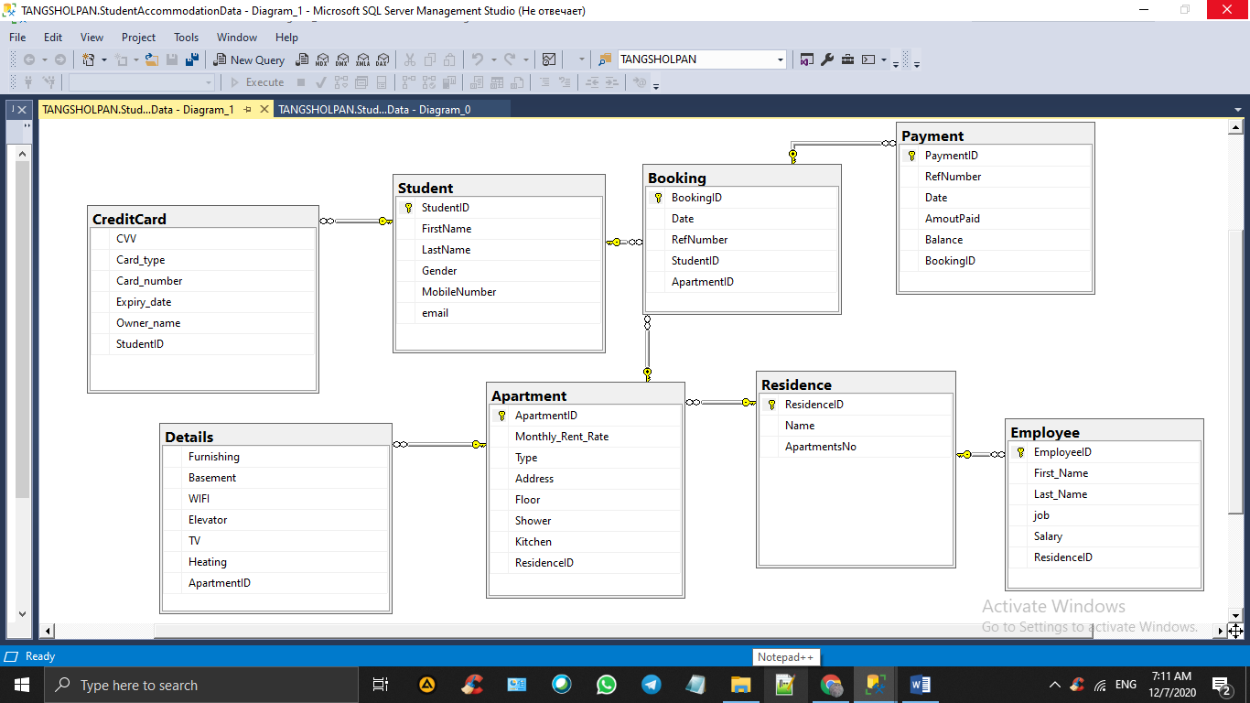

CREATE DATABASE StudentAccommodation;

CREATE TABLE Student(

StudentID int PRIMARY KEY NOT NULL,

FirstName varchar(255) NOT NULL,

LastName varchar(255) NOT NULL,

Gender varchar(50) NOT NULL,

MobileNumber varchar(50) NOT NULL,

**email varchar(255) NOT NULL,**

**);**

**INSERT INTO Student**

**VALUES(25874,'Marat','Asat','boy','87782471170','marat_02@mail.ru');**

**INSERT INTO Student**

**VALUES(98788,'Azamat','Eset','boy','87078522210','aza_02.@list.ru');**

**INSERT INTO Student**

**VALUES(10001,'Aizhan','Turarbek','girl','87471000202','aizh_aizh@mail.ru');**

**INSERT INTO Student**

**VALUES(98987,'Erzhan','Bukanov','boy','87711001789','e_02@mail.ru');**

**INSERT INTO Student**

**VALUES(26587,'Edil','Arman','boy','87078589874','edil_armai@gmail.com');**

CREATE TABLE Residence(

ResidenceID int PRIMARY KEY NOT NULL,

Name varchar(255)NOT NULL,

ApartmentsNo int NOT NULL

);

CREATE TABLE Employee(

EmployeeID int PRIMARY KEY NOT NULL,

First_Name varchar(255)NOT NULL,

Last_Name varchar(255)NOT NULL,

job varchar(200)NOT NULL,

Salary varchar(100)NOT NULL,

ResidenceID int,

FOREIGN KEY(ResidenceID)REFERENCES Residence(ResidenceID)

);

CREATE TABLE Apartment(

ApartmentID int PRIMARY KEY NOT NULL,

Monthly_Rent_Rate varchar(50),

Type varchar(255),

Address varchar(200) NOT NULL,

Floor int NOT NULL,

Shower bit NOT NULL,

Kitchen bit NOT NULL,

ResidenceID int NOT NULL,

FOREIGN KEY (ResidenceID) REFERENCES Residence(ResidenceID)

);

CREATE TABLE Details(

Furnishing bit NOT NULL,

Basement bit NOT NULL,

WIFI bit NOT NULL,

Elevator bit NOT NULL,

TV bit NOT NULL,

Heating bit NOT NULL,

ApartmentID int,

FOREIGN KEY(ApartmentID)REFERENCES Apartment(ApartmentID)

);

CREATE TABLE Booking(

BookingID int PRIMARY KEY NOT NULL,

Date date NOT NULL,

RefNumber int NOT NULL,

StudentID int,

ApartmentID int,

FOREIGN KEY (StudentID) REFERENCES Student(StudentID),

FOREIGN KEY (ApartmentID) REFERENCES Apartment(ApartmentID)

);

CREATE TABLE CreditCard(

CVV int NOT NULL,

Card_type varchar(200) NOT NULL,

Card_number varchar(200)NOT NULL,

Expiry_date date NOT NULL,

Owner_name varchar(255)NOT NULL,

StudentID int,

FOREIGN KEY(StudentID)REFERENCES Student(StudentID)

);

CREATE TABLE Payment(

PaymentID varchar(255) PRIMARY KEY NOT NULL,

RefNumber int NOT NULL,

Date date NOT NULL,

AmoutPaid int NOT NULL,

Balance varchar(50)NOT NULL,

BookingID int,

FOREIGN KEY (BookingID) REFERENCES Booking(BookingID)

);

CREATE PROCEDURE insertStudent

@StudentID INT,

@FirstName varchar(255),

@LastName varchar(255),

@Gender varchar(50),

@MobileNumber varchar(50),

@email varchar(255)

AS

insert into Student

values(@StudentID, @FirstName, @LastName, @Gender, @MobileNumber, @email)

GO

CREATE PROCEDURE updateStudent

@StudentID INT,

@FirstName varchar(255),

@LastName varchar(255),

@Gender varchar(50),

@MobileNumber varchar(50),

@email varchar(255)

AS

UPDATE Student set FirstName = @FirstName, LastName = @LastName, Gender = @Gender, MobileNumber=@MobileNumber, email=@email

WHERE StudentID = @StudentID

GO

CREATE PROCEDURE deleteStudent

@StudentID INT

AS

delete from Student where StudentID=@StudentID

GO

Task 2

